STATISTICS WITH R PROGRAMMING
PRACTICAL / ASSESSMENT RECORD
Vectors, Matrices, Arrays, Factors, Lists and Basic R Programs

Name – Sameer Ahmed G
Register Number - 192421154
Date – 11.10.2026

1. Numeric, Character and Logical Vectors
Question: Create numeric, character, and logical vectors and display their type and content.
Explanation: A vector is a one-dimensional R data structure. typeof() displays the underlying data type.
Program
num_vec <- c(10, 20, 30, 40, 50)
char_vec <- c("R", "Python", "Java", "C++")
logical_vec <- c(TRUE, FALSE, TRUE, FALSE)
print("Numeric Vector:")
print(num_vec)
print(typeof(num_vec))
print("Character Vector:")
print(char_vec)
print(typeof(char_vec))
print("Logical Vector:")
print(logical_vec)
print(typeof(logical_vec))
Output
[1] "Numeric Vector:"
[1] 10 20 30 40 50
[1] "double"
[1] "Character Vector:"
[1] "R" "Python" "Java" "C++"
[1] "character"
[1] "Logical Vector:"
[1] TRUE FALSE TRUE FALSE
[1] "logical"
Screenshot
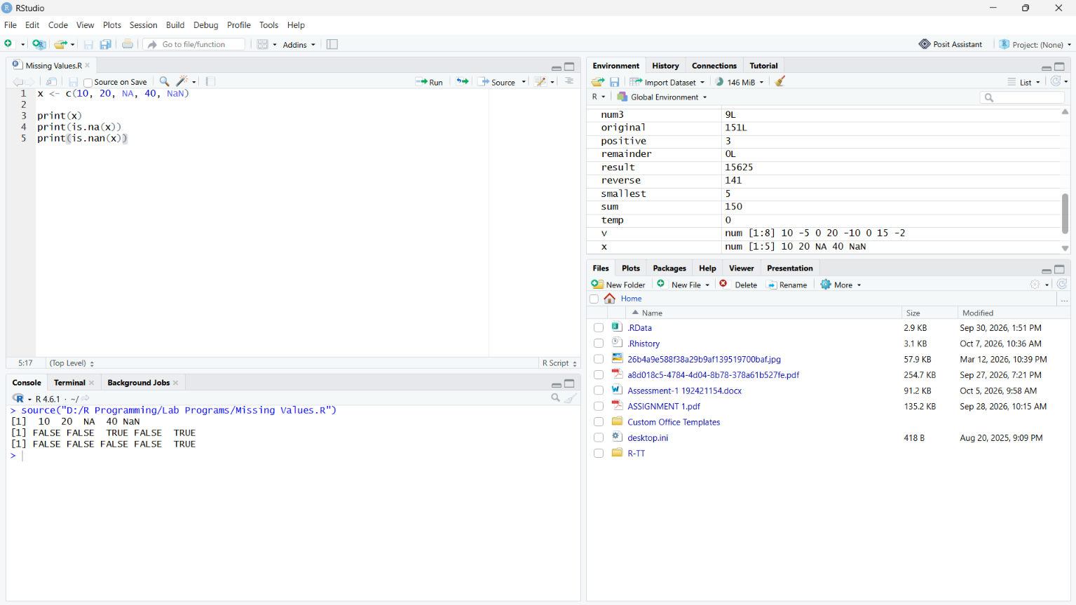

2. Labeled Matrices
Question: Create labeled matrices of sizes 5×4, 3×3 and 2×2, filled by row or column.
Explanation: matrix() creates matrices. byrow=TRUE fills row-wise; the default fills column-wise. rownames() and colnames() add labels.
Program
m1 <- matrix(1:20, nrow=5, ncol=4, byrow=TRUE)
m2 <- matrix(1:9, nrow=3, ncol=3, byrow=FALSE)
m3 <- matrix(1:4, nrow=2, ncol=2, byrow=TRUE)
rownames(m1) <- paste0("R",1:5)
colnames(m1) <- paste0("C",1:4)
rownames(m2) <- paste0("R",1:3)
colnames(m2) <- paste0("C",1:3)
rownames(m3) <- c("A","B")
colnames(m3) <- c("X","Y")
print("5 x 4 Matrix:"); print(m1)
print("3 x 3 Matrix:"); print(m2)
print("2 x 2 Matrix:"); print(m3)
Output
5 x 4 Matrix:
C1 C2 C3 C4
R1 1 2 3 4
R2 5 6 7 8
R3 9 10 11 12
R4 13 14 15 16
R5 17 18 19 20
3 x 3 Matrix:
C1 C2 C3
R1 1 4 7
R2 2 5 8
R3 3 6 9
2 x 2 Matrix:
X Y
A 1 2
B 3 4
Screenshot
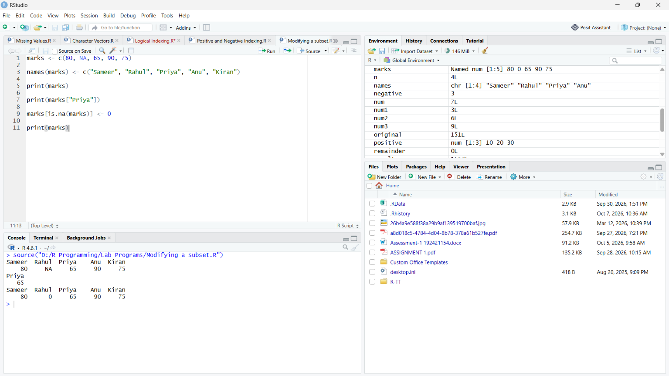

3. Three-Dimensional Array
Question: Create and display a 3D array with specified rows, columns and tables.
Explanation: array() creates multidimensional data. dim=c(3,4,2) means 3 rows, 4 columns and 2 tables.
Program
arr <- array(1:24, dim=c(3,4,2))
print("3D Array:")
print(arr)
print("Dimensions:")
print(dim(arr))
Output
3D Array:
, , 1
[,1] [,2] [,3] [,4]
[1,] 1 4 7 10
[2,] 2 5 8 11
[3,] 3 6 9 12
, , 2
[,1] [,2] [,3] [,4]
[1,] 13 16 19 22
[2,] 14 17 20 23
[3,] 15 18 21 24
[1] "Dimensions:"
[1] 3 4 2
Screenshot

4. Arrays with Dimension Names
Question: Create an array from a vector with dimension names and print specific elements.
Explanation: dimnames gives names to each dimension. Elements can then be accessed using row, column and table names.
Program
arr <- array(
1:12,
dim=c(3,2,2),
dimnames=list(
c("Row1","Row2","Row3"),
c("Col1","Col2"),
c("Table1","Table2")
)
)
print(arr)
print(arr["Row2","Col1","Table1"])
print(arr["Row3","Col2","Table2"])
Output
, , Table1
Col1 Col2
Row1 1 4
Row2 2 5
Row3 3 6
, , Table2
Col1 Col2
Row1 7 10
Row2 8 11
Row3 9 12
[1] 2
[1] 12
Screenshot

5. Factor Variables
Question: Create and manipulate factor variables using women's dataset heights and a random LETTERS sample.
Explanation: Factors represent categorical data. cut() converts numeric heights into categories; factor() creates a categorical variable from sampled letters.
Program
height_group <- cut(
women$height,
breaks=c(50,60,65,70,75),
labels=c("Short","Medium","Tall","Very Tall"),
include.lowest=TRUE
)
print("Height factor:")
print(height_group)
print("Levels:")
print(levels(height_group))
set.seed(123)
letter_sample <- sample(LETTERS, 10)
letter_factor <- factor(letter_sample)
print("Random LETTERS sample:")
print(letter_sample)
print("Letter factor:")
print(letter_factor)
print("Factor levels:")
print(levels(letter_factor))
Output
Height factor:
[1] Medium Medium Medium Medium Medium Medium Tall Tall Tall Tall
[11] Tall Tall Tall Tall Tall
Levels: Short Medium Tall Very Tall
Levels:
[1] "Short" "Medium" "Tall" "Very Tall"
Random LETTERS sample:
[1] "O" "S" "N" "C" "J" "R" "V" "Y" "I" "K"
Letter factor:
[1] O S N C J R V Y I K
Levels: C I J K N O R S V Y
Screenshot

6. R List Containing Vectors, Matrices and Functions
Question: Create an R list containing vectors, matrices and functions, and display its contents.
Explanation: Lists can contain objects of different types. Named components can be accessed using the $ operator.
Program
marks <- c(85,78,92,88)
m <- matrix(1:4, nrow=2, ncol=2)
square <- function(x) {
return(x^2)
}
student_data <- list(
marks=marks,
matrix=m,
square_function=square
)
print(student_data)
print(student_data$marks)
print(student_data$matrix)
print(student_data$square_function(5))
Output
$marks
[1] 85 78 92 88
$matrix
[,1] [,2]
[1,] 1 3
[2,] 2 4
$square_function
function(x) {
return(x^2)
}
[1] 85 78 92 88
[,1] [,2]
[1,] 1 3
[2,] 2 4
[1] 25
Screenshot

7. Basic R Programming Tasks
Question: Write R programs to find factors of a number, generate 10 random integers between -50 and 50, and print 1–100 using FizzBuzz logic.
Explanation: The modulus operator %% finds remainders. sample() generates random values. FizzBuzz checks divisibility by 15, then 3 and 5.
Program
# A. Factors
n <- 36
cat("Factors of", n, ": ")
for(i in 1:n) {
if(n %% i == 0) cat(i, " ")
}
cat("\n")
# B. Random integers
set.seed(123)
random_numbers <- sample(-50:50, 10)
print(random_numbers)
# C. FizzBuzz
for(i in 1:100) {
if(i %% 15 == 0) {
print("FizzBuzz")
} else if(i %% 3 == 0) {
print("Fizz")
} else if(i %% 5 == 0) {
print("Buzz")
} else {
print(i)
}
}
Output
Factors of 36 : 1 2 3 4 6 9 12 18 36
[1] -21 -10 25 49 -18 31 -2 -42 37 -7
FizzBuzz:
1, 2, Fizz, 4, Buzz, Fizz, 7, 8, Fizz, Buzz, ...
98, Fizz, Buzz
Screenshot

